Kinetics Activity Handout Form

Name: __________________________________________ Date:__________________________

Note: You are strongly encouraged to use a spreadsheet program (excel), or other mathematical program (matlab, Mathcad, mathematica, R etc.) to complete this assignment. The blackboard site has links to a video introducing excel, along with excel spread sheets that contain the data for question 3.

1) (4 pts) This form accompanies the online kinetics activity. Please use it to answer the following questions:
Step-1
a) Attach the printout of your kinetic trace and fill in the following data table:

Volume of dye solution
Concentration of bleach solution
Volume of bleach solution

b) What are the initial concentrations of [Dye] and [Bleach] for your experiment?

Step-2
c) What is the value of the pseudo rate constant for your experiment?

Step-3
d) Design an experiment to determine the order of the reaction with respect to [bleach]. Attach a printout of your kinetic trace from your experiment. Give the order with respect to [bleach] and explain how you determined this from the experiment.

Step-4
e) What is the proportionality constant, ε l, in Beer’s law, abs = ε l [dye]? Include units in your answer. (Abs is unitless and [dye] is in mol/L or M.)

f) Calculate the rate constant (k) for the reaction of Yellow 6 with bleach to 2 significant figures, assuming the concentration of [dye] and [bleach] are in M. Write the rate law for the reaction (including both the numerical value of k, and the order of the reaction with respect to [dye] and [bleach]).

3) (4 pts total) The following shows results from experiments similar to those of the online tutorial, but with different dyes and bleach. The reaction has 1:1 stoichiometry.

dye + bleach colorless products

The initial solutions have the following concentrations
Blue dye: 3.20 x 10⁻⁵ M Red dye: 5.60 x 10⁻⁵ M Bleach: 0.150 M

The absorbance was measured at various dye concentrations and the results are summarized below. (Note: This data also available in the file: http://collective.chem.cmu.edu/kinetics/documents/dyeData.xlsx )

[blue dye] | abs |  | [red dye] | abs
0 | 0 |  | 0 | 0
3.20E-06 | 0.08 |  | 5.60E-06 | 0.085
6.40E-06 | 0.16 |  | 1.12E-05 | 0.17
9.60E-06 | 0.24 |  | 1.68E-05 | 0.255
1.28E-05 | 0.32 |  | 2.24E-05 | 0.34
1.60E-05 | 0.4 |  | 2.80E-05 | 0.425
1.92E-05 | 0.48 |  | 3.36E-05 | 0.51
2.24E-05 | 0.56 |  | 3.92E-05 | 0.595
2.56E-05 | 0.64 |  | 4.48E-05 | 0.68
2.88E-05 | 0.72 |  | 5.04E-05 | 0.765
3.20E-05 | 0.8 |  | 5.60E-05 | 0.85
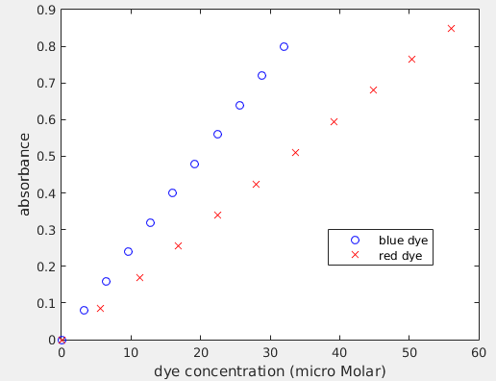

Experiments were then performed by mixing the following volumes of dye and bleach solutions and monitoring absorbance versus time.
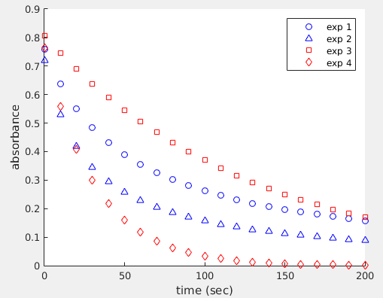

Experiment 1: blue dye: 9.50 mL bleach: 0.500 mL
Experiment 2: blue dye: 9.00 mL bleach: 1.00 mL
Experiment 3: red dye: 9.50 mL bleach: 0.500 mL
Experiment 4: red dye: 9.00 mL bleach: 1.00 mL

The results of the experiments are available in the dyeData.xls excel file accompanying this homework, and are plotted to the right.

a) (2 pts) Determine the rate law of the reaction (including the rate constant, and order with respect to [dye] and [bleach]):

blue dye + bleach colorless products

Please describe your approach, including any calculations or plots used for the analysis.

b) (2 pts) Determine the rate law of the reaction (including the rate constant, and order with respect to [dye] and [bleach]):

red dye + bleach colorless products

Please describe your approach, including any calculations or plots used for the analysis.

